**Sentiment Analysis Report**

**Introduction**

* This report aims to provide insights and recommendations on sentiment analysis for restaurant visitors and their ratings.

**Data** **Source**

* The data has been taken from the Kaggle platform.

**Analysis Tools**

* Python **.**

**Insights**

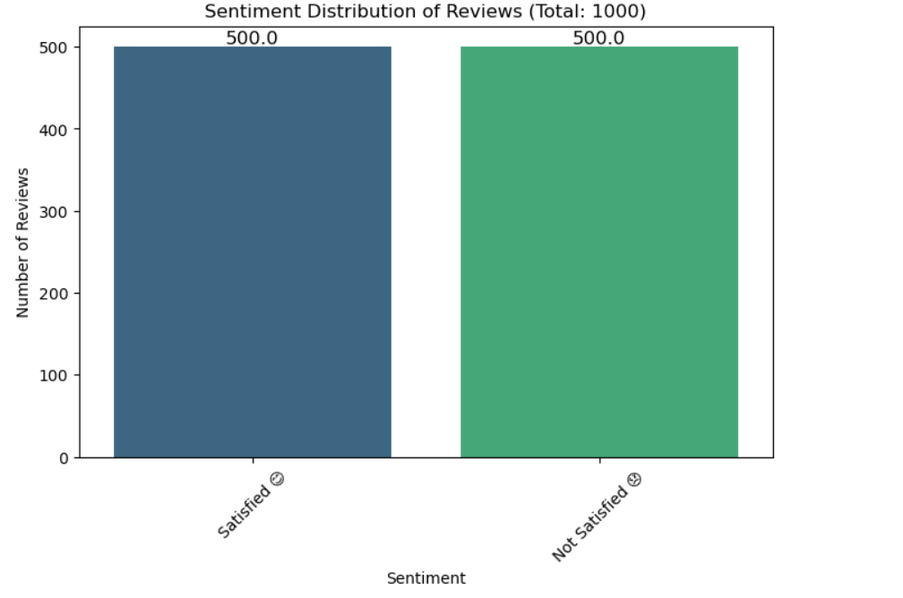

**Balanced Sentiment Distribution**:

* The chart indicates an equal distribution of sentiments among the reviews, with 500 reviews categorized as "Satisfied" and 500 as "Not Satisfied." This suggests that customer feedback is evenly split, highlighting a diverse range of experiences with the product or service.

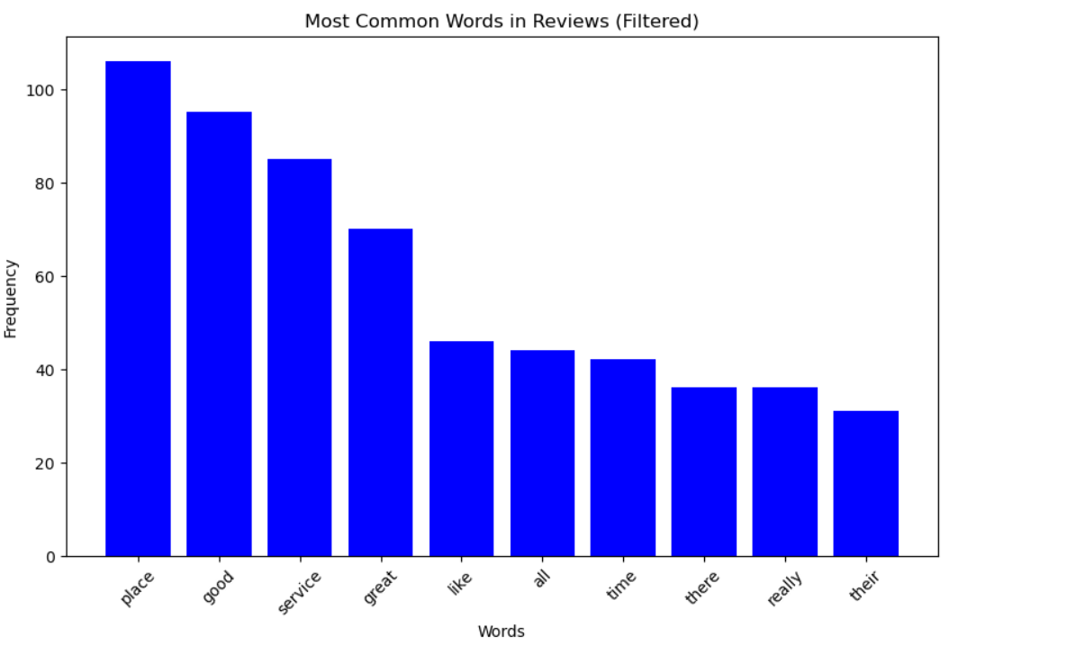

**High Frequency of Positive Terms**:

* The most common words in the reviews include "place," "good," "service," and "great." This indicates that customers generally associate the business with positive experiences, particularly highlighting the quality of the service and the overall environment.

**Focus Areas for Marketing**:

* The prominence of words like "good" and "great" suggests that these attributes can be effectively leveraged in marketing materials. Emphasizing the positive aspects noted by customers can attract more potential clients and reinforce the brand's reputation.

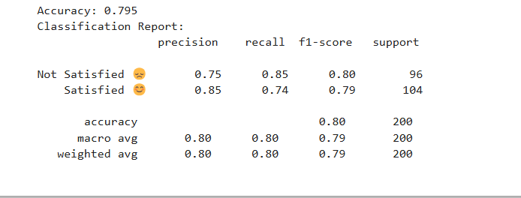

• **Overall Accuracy**:

* The model has an accuracy of **79.5%**, indicating that it correctly classifies a majority of the reviews. This is a solid performance, but there is room for improvement.

• **Class Performance**:

* **Not Satisfied**:
  + **Precision**: 0.75
  + **Recall**: 0.85
  + **F1-Score**: 0.80
* **Satisfied**:
  + **Precision**: 0.85
  + **Recall**: 0.75
  + **F1-Score**: 0.79
* The precision and recall values suggest that the model is better at identifying "Satisfied" reviews but has a relatively high recall for "Not Satisfied" reviews, indicating it effectively captures most negative sentiments.

Thank you